**`Fixes that still need to be made. 06 May 2019**

**+ /_ not working**

This is not working on the main page. Please can this be fixed.

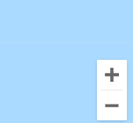

**Pin Drops not appearing on the Map**

A Key part of the website is the pin drops on the map. This needs to be working for every job listing and profile listing. Please can this be fixed

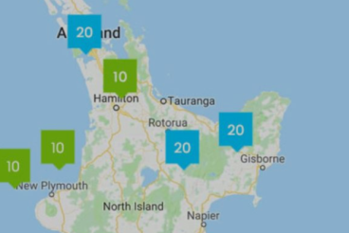

**Front page search not working**

I have tried using the search to pull up a job I know is there “Truck driver” but it returns no results.

Please can this be fixed. -> **done**

Also the search for work button needs to be green (matching the other button) -> **done**

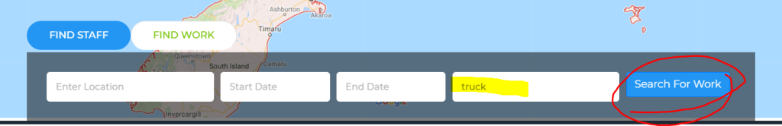

**Searches not working and wrong fields in “intensity of work”**

If you put anything in the searches for Looking for work and looking for jobs, below they do not bring anything up. -> **done**

The sort by filters are not working -> **done**

Under “intensity of work” this is bring through the “industry” this is incorrect, it needs to show “below average, average, or above average” -> **done**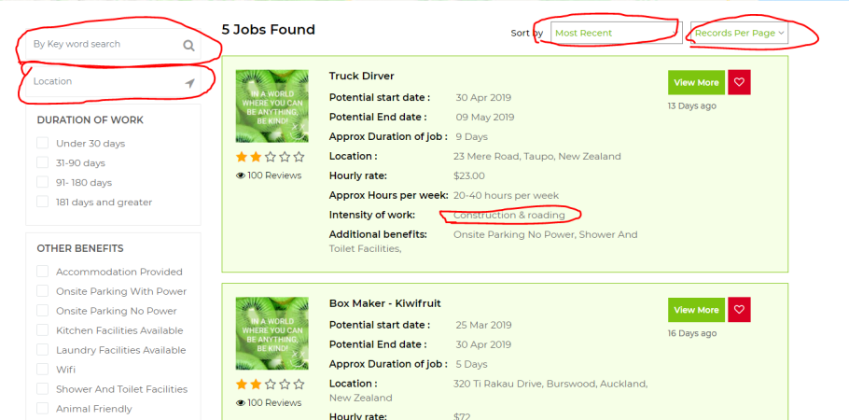

Information not pulling through correctly to the forms (if data is blank show is NA)

Also “level of English” Should show “below average” not just “below” -> **done**

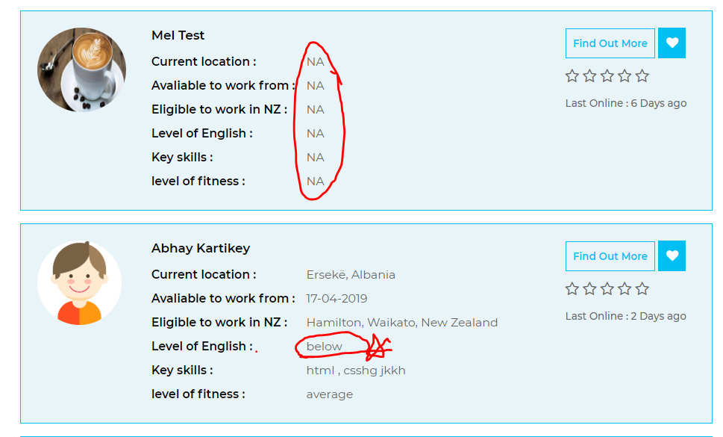

Also it is allowing an non registered person to view the details…. This should not happen it should ask them to register to find out more information. -> **done**

**Bold the headings in the profile.**

Please can the headings of each section be bigger font and bolder. It makes it difficult to read otherwise. -> **done**

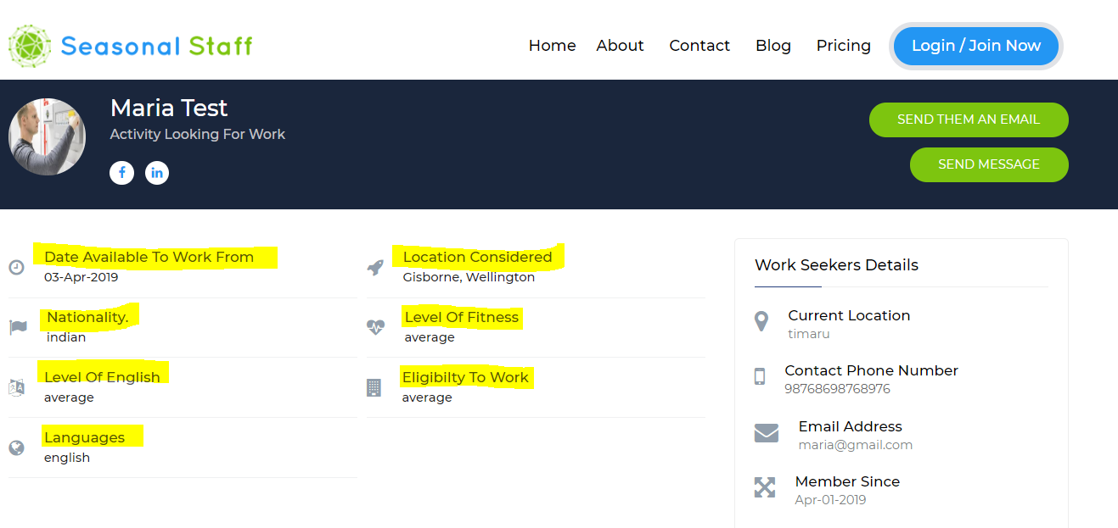

-> **done**

**The process is incorrect here.**

It has allowed a user to get personal information of a staff member without logging in…eg the phone number and email are visable so they would be able to contact that member without logging in. -> **done**

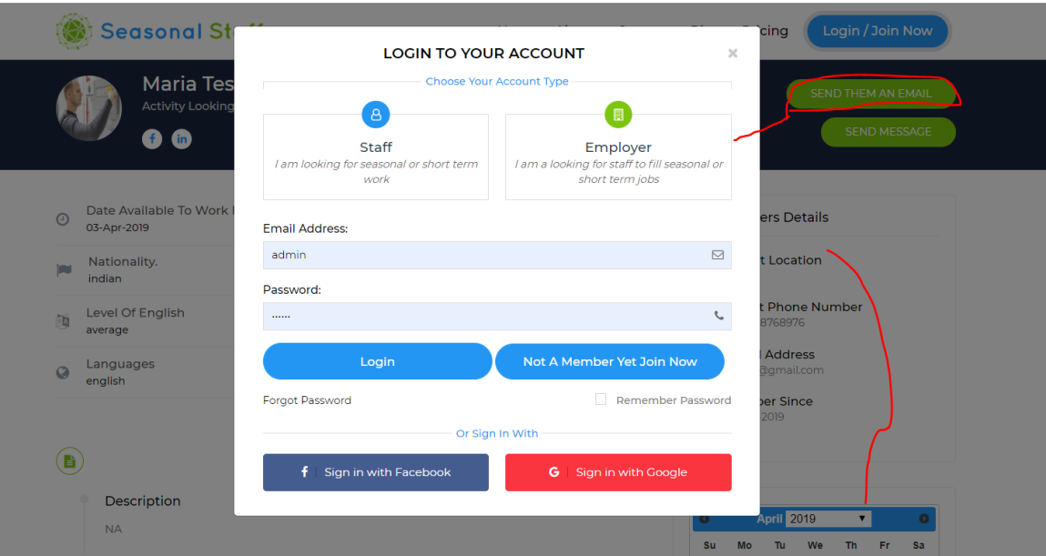

This needs to be changed to requiring the user to log in when they hit the “Find out more” button. (see below)

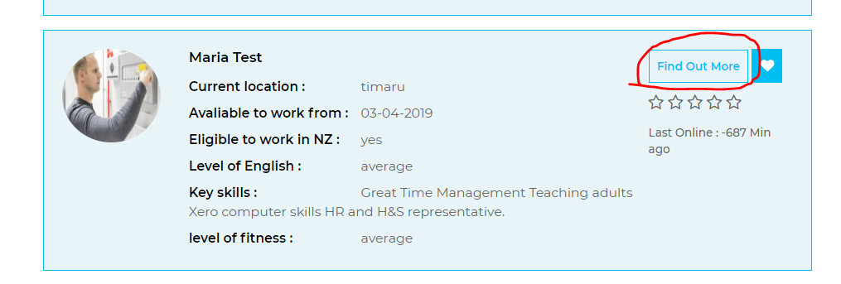

It is correct for finding work (please ensure they are the same)

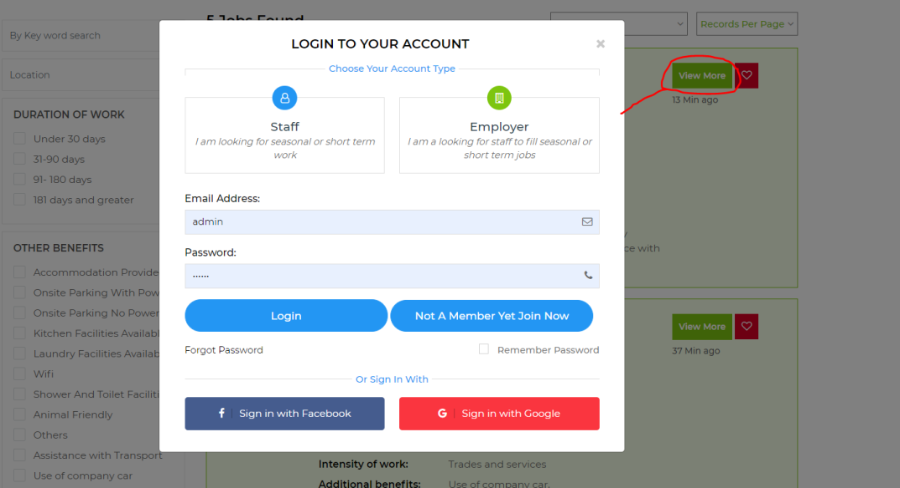

Please can you increase the size of this message being that small it is easy to miss and could cause some frustration with users. -> **done**

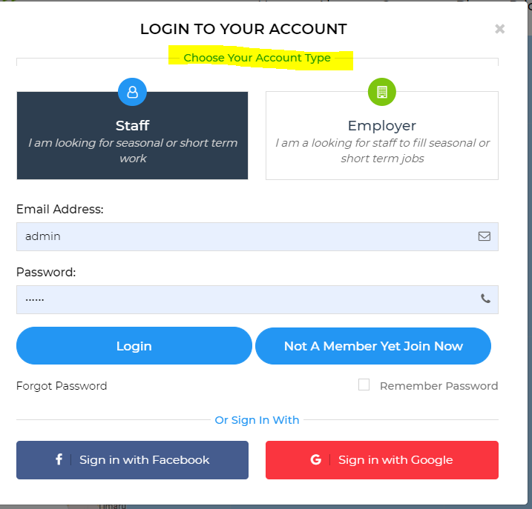

**Error Message not displaying correctly& need to increase the size of the I am over 18 button.**

Please can the box where the error message is show be a lot more obvious and tabulated correctly

Please can the I am over 18 button be “A lot bigger” it is quite easy to miss.

Also when an error is made in the signup can it take you back to the sign up page rather than to the main page. It needs to be obvious what the error is .at the moment there is not indication as to why the error has occurred.

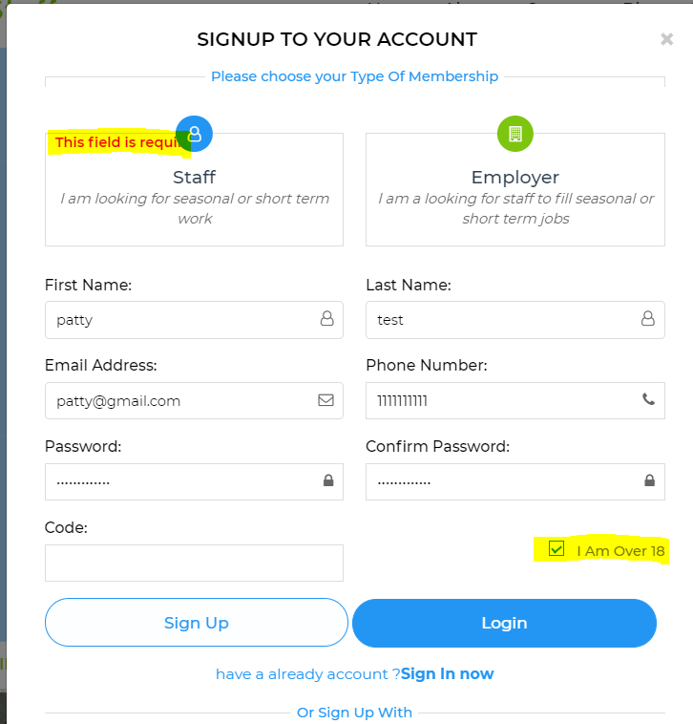

**Password can be viewed or hidden.**

Please can we have the feature where you can display what your password is…. Or hide it…(see below example) it can be really frustrating if you think you are getting your password right and you cannot see it correctly. As the font is quite small.

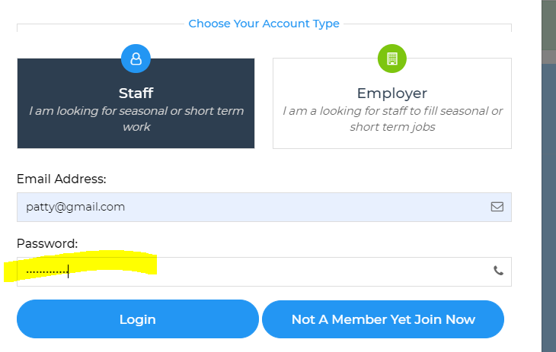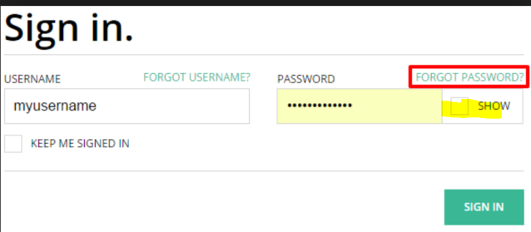

Once a user has logged in for the first time, we need to prompt them to complete their profile.

This is a once only prompt - This should not keep popping up as a reminder (as that would get really annoying) Please can we add this prompt.

Saying some thing like “ Please complete your profile before proceeding” with and “ok” button that the user can press.

We need to ensure that the profile is fully completed, in order for the “Employer” to “list a job” or “contact” a staff member. If they don’t have their profile and details filled in they are not able to contact user or put up an advert.

Also the Username is confusing with the @symbol. Can the @ sign be removed. Perhaps we can have a “I” which says “the is the username non registered users will see”

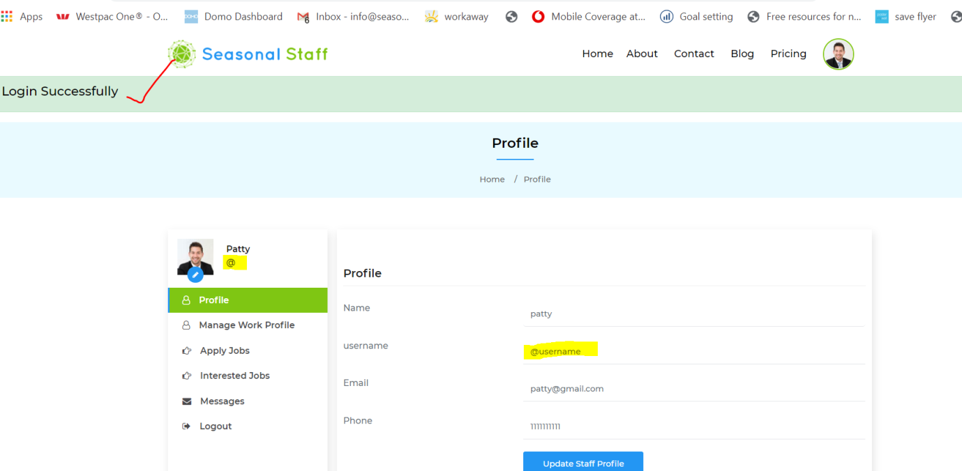

Some fixes to be done on this page. (see below as highlighted)

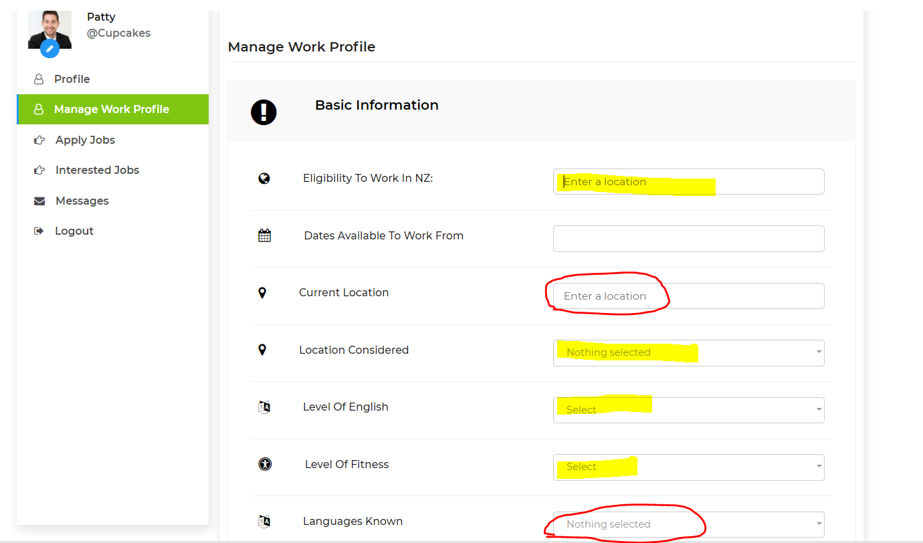

“Eligibility to work in NZ” This is meant to be a drop down list that we have provided option to attach a copy of work visa.

“Current location” please change the wording from “Enter a location” to “Enter your closest suburb” this search box is not bringing up New Zealand locations – please can we ensure it brings up New Zealand locations – the country seems to be set as albania

“locations considered” please change the wording from ”Nothing selected” to “Enter all locations considered”

“level of English” please ensure that they are in the correct order “Below Average, Average, Above Average”

“level of fitness” please ensure that they are in the correct order “Below Average, Average, Above Average”

“languages Known” Please can you add “Maori” below English, Also please add “other” at the bottom.

“Nationality” Please can this be a free text box so that they can type in their own nationality as there are too many to list.

“Contact” This phone number should pull through from the log in information

“member since” this should pull through from the date that they were first registered. The user should not need to imput this field.

“Description” Please can you change this title to” Tell us about yourself”

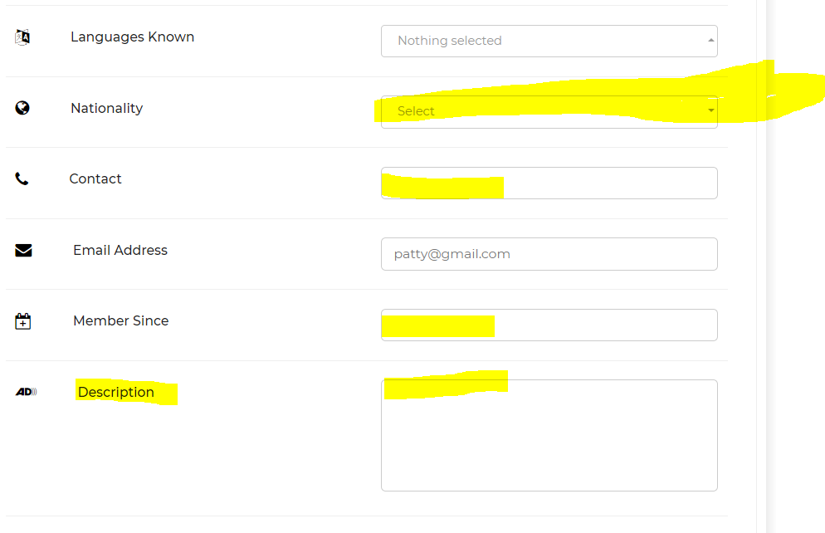

Employment history does not show up in staff user profile.

Please can you change the order of the below, so that the “Skills and Attributes” Section is above the Employment Histroy.

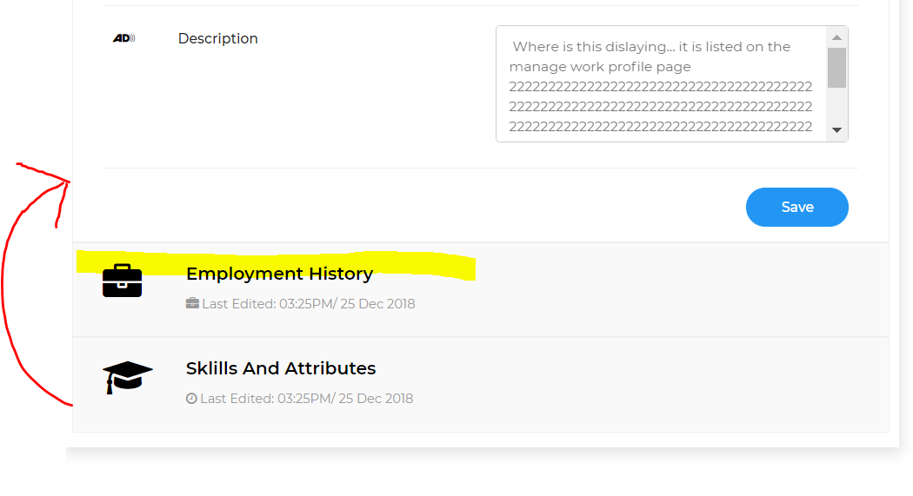

**Skills and attribute section needs finishing.**

As discussed in previous work requests.

In the Skills and attributes box this needs to be bullet pointed. So Every time they start a new line it shows as a bullet point. (perhaps) Change “Skills and Attributes” to “List your Skills and Attributes”

Please Remove “ Description “ and the text box. This is not needed here.

“Licences and Endorsements” Not all of the licences and endorsements are listed here, please ensure they are all added here please.

Please remove “Add more courses” this is not needed here.

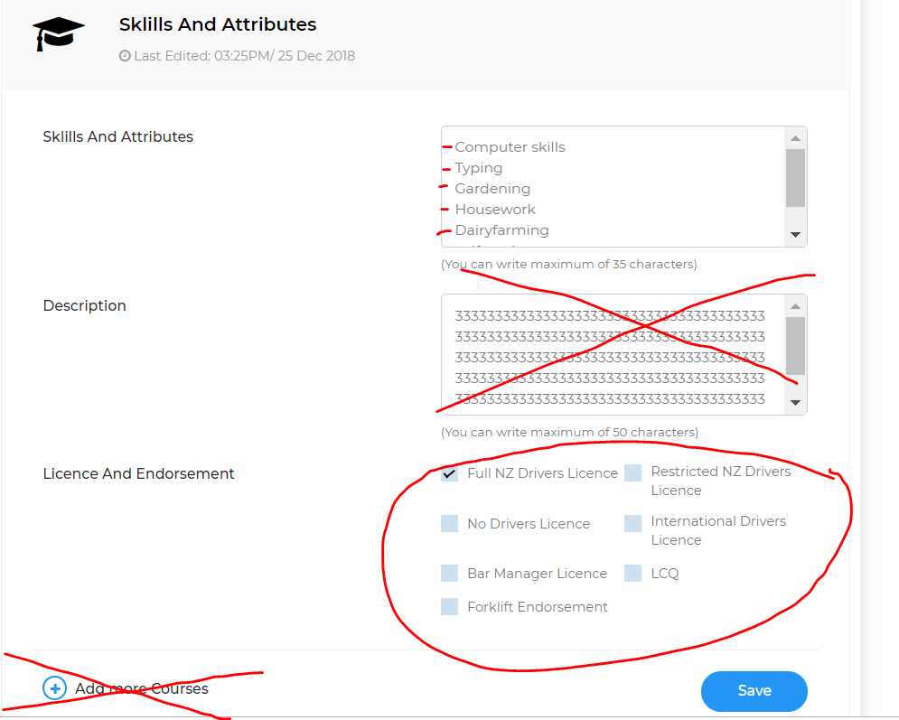

**Employment Histroy**

This section is good apart from it does not appear when doing the profile. Please ensure it is added

Where it says “Add more Jobs” please change this to “Add another Job”

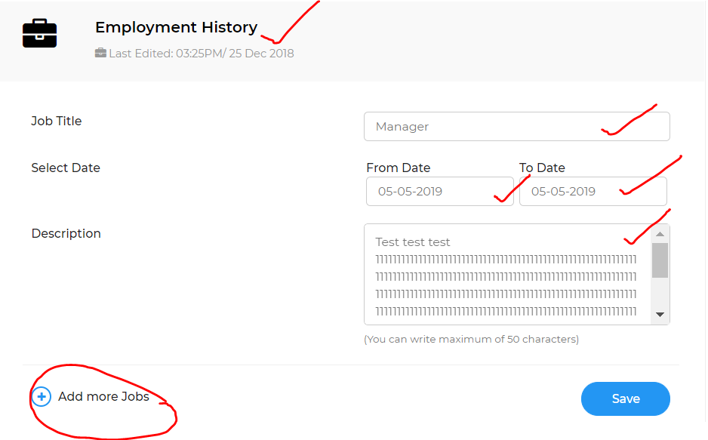

Can this be more colourful, it looks very dull and boring. Can we add some colour here please.

Perhaps three slightly darker shades to show that they are different sections

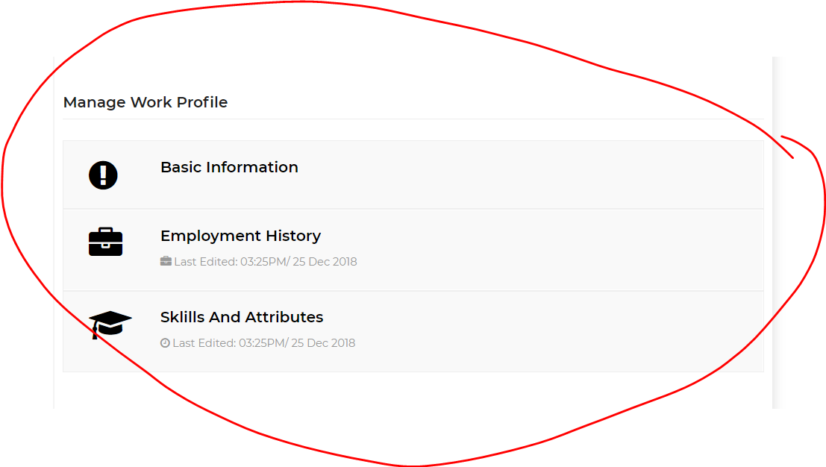

Very important.

The user needs to be able to see what their profile is going to look like… before… it is uploaded. We we need to add a “Preview profile “ Which is what they would see “before “ it goes live”

Once they have previewed they can either “ go back and edit” or “submit” please can you put this process in. Thanks